Ministry of Higher Education and Scientific Research
University of Diyala
College of Veterinary Medicine

Hepatoprotective effect of aqueous – methanol extract of Cordia dichotoma against experimentally induced hepatitis in rabbits

A research submitted to council of College of Veterinary Medicine
as part of fulfillment to obtain the Bachelor’s Degree
in Veterinary Medicine and Surgery

By Hawraa Salah AL-Deen AL bayati

Under supervision of

Dr. Ahmed Hanash Khlaf

2017

اي من الذكر الحكيم معبرة عن المرض والشفاء

بسم الله الرَّحمن الرَّحيم

فَتَعَالَى اللَّهُ الْمَلِكُ الْحَقُّ وَلا تَعْجَلْ بِالْقُرْآنِ مِنْ قَبْلِ أَنْ يُقْضَى إِلَيْكَ وَحْيُهُ وَقُلْ رَبِّ زِدْنِي عِلْماً

صدق الله العظيم

Dedication

الى من سهرت الليالي واحتضنتني ولم تبخل علي
امي الغالية
الى من وقف الى جانبي وتعب من اجل سعادتي
ابي العزيز
الى من شجعني وجعلت الحياة وجعلو الحياة جميله في عيني
ا اخواتي واخي الغالي
الى فلدات كبدي وبهجتي في الحياة
ايلاف\زكية\ايهاب\مصطفى
الى دكتوري العزيز
دكتور احمد حنش

حوراء صلاح الدين البياتي

شكر وتقدير
اقدم شكري وامتناني الى جميع من اعانوني وساعدوني في اخراج هدا البحث
بفضلهم وجهدهم على الآراء القيمة التي ابدوها لي وخصوصا مشرف البحث
الدكتور احمد حنش والى الهيئة التدريسية في القسم عموما وراجيا
من الله ان اصبت اكثر مما اخطأت وان استفدت مما استبدلت من جهودي
املا ان اكون قد اعطيت الموضوع بعض حقه واسال الله ان يعلمنا
ما ينفعنا وينفعنا بما علمنا

Abstract
Liver dysfunction is a major health problem. Excessive drug therapy, free radicals, environmental pollutants, and alcoholic intoxicants are the main causes of liver disorders. To evaluate the hepatoprotective activity of aqueous – methanol (30:70%) extract of Cordia dichotoma fruit against paracetamol – induced liver injury in experimental rabbits. The study was conducted on 16 mature, male rabbits, of 1-2 years old, 1-1.9 kg b. wt. the animals were kept in a room of 20-27 ºC, left ad libitum for water and food (green and concentrated). After 2 weeks of acclimatization, the rabbits divided into four groups of 4 in each. Rabbits of 1st group left without treatment with extract nor exposed to paracetamol as control group. While those of 2nd group were treated with aqueous -methanol extract (30:70%) of extract at a dose rate of 300 mg / kg b.wt. for 9 days, then hepatitis was induced through exposure to paracetamol at a dose rate of 250mg/ kg b.wt. intraperitoneal for 9 days, the treatment with extract continue till end of experiment. Meanwhile rabbits of 3rd group were left without treatment in the first 9 days then hepatitis was induced through exposure to paracetamol at a dose rate of 250 mg/ kg. b.wt. with treatment with the extract at a dose rate of 300 mg / kg b.wt. for 9 days. In those of 4th group hepatitis was induced with paracetamol at a dose rate of 250 mg / kg b.wt. for 9 day, without treatment with the extract. All animals in day 18th were euthanized to collect blood serum for estimation of serum enzymes (RBS, ALT, AST, TSB, TSP, BUN, Creatinine), in addition to sample from liver for histopathological examination. The dependent parameters, clinically were included heart rates, respiratory rates, body temperature, body weight, with some hematological examination, Hb concentration and PCV, and clotting, bleeding time, total and differential leucocytes counts were taken for three times. The results revealed that the levels of biochemical parameters were increased in paracetamol intoxicated rabbits when comparted with the normal group. The extract at 300 mg /kg b.wt. exhibit significant reduction in biochemical parameters. Hepatoprotective activity was also confirmed by histopathological findings. In conclusion these results suggest that Cordia fruit aqueous – methanol extract possess significant hepatoprotective effect against paracetamol – induced hepatotoxicity and this may be due to the presence of flavonoids and tannins.

List of contents
Series | Title | Page
1 | Dedication | A
2 | Acknowledgement | B
3 | Abstract | C
4 | List of content | D
5 | List of Picture | E
6 | List of Tables | F
7 | Introduction | 1
8 | Literature review | 2
9 | Material and Methods | 5
10 | Results | 8
11 | Discussion | 11
12 | Conclusion | 13
13 | References | 14
14 | Abstract in Arabic | أ

List of pictures
Series | Items | page
1 | Picture showing: not treated with extract nor exposed to paracetamol

List of Tables
Series | Title | Page
1 | Table-1- showing the body weight, body temperature, respiratory rates, heart rate of rabbits in the experiment
2 | Table-2- showing total erythrocytes count, Hb concentration, Packed cell volume, Mean corpuscular volume, Mean corpuscular hemoglobin, mean corpuscular hemoglobin concentration
3 | table -3- showing total and differential leucocytes count
4 | table 4- showing bleeding and clotting time of rabbits in experiment
5 | table-5- showing gastric PH, Volume, free acidity, total acidity, Number of gastric lesions and percent of protection
6 | table-6- showing the values of RBS, ALT, AST, TSB, TSP, BUN, Creatinine of rabbits under the experiment

1.Introduction
The liver is a vital organ of paramount importance involved in the maintenance of metabolic functions and detoxification of the exogenous and endogenous challenges like xenobiotics, drugs, viral infections and chronic alcoholism (Bhardwaj, A. et al., 2011). Plant- derived natural products have received considerable attention in recent years due to their diverse pharmacological actions including antioxidant and hepatoprotective activity (Wang, et al., 2004).
Liver disease is a serious problem in developing countries and as cause of morbidity and mortality throughout the world. It has been estimated in recent reports that 10% of world population is affected with liver diseases including hepatitis, alcoholic steatosis, fibrosis, liver cirrhosis and hepatocellular carcinoma. Morbidity and mortality resulting from liver diseases is a major public health problem worldwide (Zhang, et al., 2013). Medicinal plants play a vital role in the management of liver disorder in the developing world for primary health care because they are inexpensive, possessing minimal or no side effect and easy availability in nature (Sheetal and Singh, 2008). Medicinal plants have been used as sources of medicine in virtually all cultures. During the last decade, the use of traditional medicine ™ has expanded globally and is gaining popularity. Up to 40% of modern drugs are derived from natural sources, using either the natural substance or a synthesized version. In recent years, there has also been growing interest in alternative therapies and the use of natural products, especially those derived from plants (Rates, 2001 and Schmeda- Hirschmann and Yesilada, 2005). Plant extracts are some of the most attractive sources of new drugs and have been shown to produce promising results for the treatment of gastric ulcer (Alkofahi and Atta, 1999 and Schmeda- Hirschmann and Yesilada, 2005).
Therefore, to justify the traditional claims the present study was undertaken to find out if aqueous - methanol extract of Cordia dichotoma fruits demonstrates the hepatoprotective activity against paracetamol– induced liver damage in rabbits

2.Literature reviews
2.1. Crude extracts of fruits, herbs, vegetables, cereals, and other plant materials rich in phenols are increasingly of interest in the food industry because they retard oxidative degradation of lipids and thereby improve the quality and nutritional value of food. Antioxidants are compounds that can delay or inhibit the oxidation of lipids or other molecules by inhibiting the initiation or propagation of oxidative chain reactions (Sun, et al., 2002).
The anti-oxidative effect is mainly due to phenolic components, such as flavonoids (Pietta, 1998), phenolic acids, and phenolic diterpenes (Simon J.E., et al., 1999). Typical phenols that possess antioxidant activity have been characterized as phenolic acids and flavonoids (Ka”hko” nen, M.P., et al., 1999). Phenolic acids have repeatedly been implicated as natural antioxidants in fruits, vegetables, and other plants.
Medicinal plants play a vital role in the management of liver disorder in the developing world for primary health care because they are inexpensive, possessing minimal or no side effect and easy availability in nature (Sheetal and Singh, 2008).
The liver is the key organ regulating homeostasis in the body. It is involved with almost all the biochemical pathways related to growth, fight against disease, nutrient supply energy provision and reproduction (Ward et al., 1999). The liver is expected not only to perform physiological functions but also to protect the hazards of harmful drugs and chemicals. Jaundice and hepatitis are two major hepatic disorders that account for a high death rate (Pang et al., 1992). Presently only a few hepatoprotective drugs and those from natural sources are available for the treatment of liver disorders. More than 900 drugs have been implicated in causing liver injury (Friedman et al., 2003) and it is the most common reason for a drug to be withdrawn from the market. Drug – induced liver injury is responsible for 5% of all hospital admissions and 50% of all acute liver failures (Friedman et al., 2006; Ostapowicz et al., 2002).
2.2. The liver regulates many important metabolic functions, detoxification, and secretory functions in the body. Hepatic injury is associated with distortion of these metabolic functions (Wolf, P.L.,1999). Thus, liver diseases remain one of the serious health problems and its disorders are numerous with no effective remedies.
The liver plays an astonishing array of vital functions in the maintenance, performance and regulating homeostasis of the body. It is involved with almost all the biochemical pathways to growth, fight against disease, nutrient supply, energy provision and reproduction (Sharma et al., 1991). The major functions of the liver are carbohydrate, protein and fat metabolism, detoxification, secretion of bile and storage of vitamin. Thus, to maintain a healthy liver is a crucial factor for the overall health and wellbeing (Subramaniam and Pushpangadan, 1999).
Hepatotoxicity implies chemical- driven liver damage. Certain medicinal agents, when taken in overdoses and sometimes even when introduced within therapeutic ranges, may injure the organ. other chemical agents, such as those used in laboratories and industries, natural chemicals (e.g. microcystins) and herbal remedies can also induce hepatotoxicity. Chemicals that causes liver injury are called hepatotoxins. More than 900 drugs have been implicated in causing liver injury and it is the most common reason for a drug to be withdrawn from the market. Chemicals often cause subclinical injury to liver which manifests only as abnormal liver enzyme tests. Drug- induced liver injury is responsible for 5% of all hospital admission and 50% of all acute liver failure. More than 75 % of cases of idiosyncratic drug reactions result in liver transplantation or death (Ostapowicz et al., 2002).
2.3.Non-Steroidal Anti-Inflammatory Drugs
Acetaminophen, Nimesulide, Diclofenac, Ibuprofen are Non- steroidal anti-inflammatory drugs) (NSAID_{S}) which are the centerpiece of pharmacotherapy for most rheumatological disorders, and are used in large numbers as analgesics and antipyretics, both as prescription drugs and over the counter purchases. It is the most important cause of the drug induced toxic injury to several organ systems, including well known injury to gastrointestinal tract and kidneys. In overdose, the analgesic / antipyretic acetaminophen producers centrilobular hepatic necrosis (Walker, 1997). The mechanism of liver injury in NSAIDs is thought to be immunological idiosyncrasy (Zimmerman, 1990).
2.3.1.Mechanism of toxicity of NSAIDs
Recently, a number of in vitro animals have been used to investigate the possible mechanisms of NSAID’s – related hepatotoxicity. Studies using rat liver mitochondria and freshly isolated rat hepatocytes showed that diphenylamine, which is common in the structure of NSAIDs uncouples oxidative phosphorylation, decreases hepatic ATP content and induces hepatocyte injury. Incubation of mitochondria with diphenylamine, mefenamic acid or diclofenac caused mitochondrial swelling. In addition, a spectral shift of the safranin- binding spectra to mitochondria occurred, indicating the loss of mitochondrial membrane potentials (one of the characteristics of uncoupling of oxidative phosphorylation). Paracetamol administration causes necrosis of the centrilobular hepatocytes characterized by nuclear pyknosis and eosinophilic cytoplasm followed by large excessive hepatic lesion., The covalent binding of N- acetyl- P- benzoquinoneimine, an oxidative product of paracetamol to sulfhydryl groups of protein, result in lipid peroxidative degradation of glutathione level and thereby, produces cell necrosis in the liver (Masubuchi et al., 2000; Bort et al., 1999).The liver can be injured by various chemicals and drugs. In the present study. When liver cells damage cellular enzymes like AST, ALT, ALP and serum bilirubin present in the hepatocytes, leaks into the circulation. Histopathological changes such as steatosis (fatty changes in hepatocytes) and fibrosis were observed.
2.4.1.Cordia myxa
Cordia Family (Boraginaceae). the plant is used in the treatment of hepatic infections, cirrhosis of the liver and inflammation of the lymph nodes. It is also used to treat albumin present in the urine. Cook islanders use the leaves in remedies for abdominal swelling and urinary tract infections) (Weiner, M.A. et al., 1992); however, there are no ethnomedicinal information and scientific findings for the above said traditional claim for hepatic disorders.) ,
Cordia myxa L. locally known as Bumber is popularly used for its efficacy in chest and urinary infections (Alami and Macksad, 1974). It is also used for its anthelmintic, diuretic, demulcent, antidiarrheal, anti-gastric, antiworm properties and also liver tonic. Several preparations of Cordia species have been used in traditional medicine for osteo-articular diseases, analgesic, anti-inflammatory and anti-arthritic activities of C. francisci, C. martinicensis, C. myxa, C. serratifolia and C. ulmifolia have been studied in rats (Ficarra et al., 1995). the anti-inflammatory properties of the C. myxa fruit preparation in the treatment of experimental colitis have been demonstrated by(Al-Awadi et al.,2001).however, there are few data about its pharmacological effects on gastrointestinal system as well as about its possible toxic properties and chemical composition. This promoted as to investigate the effect of C. myxa fruit extract (CME) o indomethacin induced gastric ulcer in rats as well as to evaluate its acute toxicity and qualitative phytochemical profile.
Sugar, flavonoids and alkaloid content of five Cordia species have been analyzed by TCL and reverse phase HPLC chromatographic techniques (Ifzal and Qureshi, 1976). These species have yielded four flavone glycosides, robinin, rutin, datiscoside and hesperidin one flavone aglycone, dihydrobinbetin and two phenolic derivatives, clorgenic and caffeic acids. C. myxa seed oil (Tiwari et al, 1980). And its photosynthetic pigments have been analyzed (Afzal et al., 2004).
Cordia dichromato L.(Boraginaceae), commonly known as Lasaura/ lasura. It is used as immunomodulatory, antidiabetic, anthelmintic, diuretic and hepatoprotective in folklore medicine. Cordia dichromato seeds has disclosed the presence of α –amyrins, botulin, octacosanol, luperol-3-rhamnoside, β-sitosterol, β-sitosterol-3-glucoside, hentricontrol, hentricontane, taxifolin-3-, 5- dirhmnoside and hesperitin-7-rhamnoside (Srivastava SK, and Srivastava SD, 1979). The seed contain α- amyrin and toxifolin 3,5, dirhamnoside, which shows significant anti-inflammatory activity by an oral dose of 1 gm/ kg in albino rats (The Wealth of India, Raw Materials),1950). The seed of this plant reported to contain fatty acids and flavonoids (Srivastava SK, and Srivastava SD, 1979).
The results of preliminary phytochemical screening of the ethanolic extract of Cordia subcordata lam. revealed that presence of alkaloids, flavonoids, carbohydrates, glycosides, tannins, terpenoids and absence of saponins and steroids (Saravana, A. et al., 2009) The CCl₄ only treated animals exhibited a significant increase the levels of AST, ALT, alkaline phosphatase and acid phosphatase and also total bilirubin and urea when compared to the normal control group on both 4th and 8th day, indicating hepatocellular damage. The EECS at tested doses produced a significant reduction in the CCl₄ – induced elevated levels of AST, ALT. alkaline phosphatase, and acid phosphatase, also total; bilirubin and urea when compared to the CCl₄ only treated animals after 3 days of treatment and reduced furthermore to the normalcy on 8th day although the lowest dose (100mg/kg) tested could produce significant reduction even after 3 days of treatment.

Materials and methods
The study was conducted on 16 mature, male rabbits, of 1-2 year old, 1-1.9 kg b. wt. the animals were kept in a room of 20-27 ºC, left ad libitum for water and food (green and concentrated). After 2 weeks of acclimatization, the rabbits divided into four groups of 4 in each. Those of 1st group were left without treated with aqueous- methanol of Cordia dichotoma extract nor to paracetamol, as control group. Those of 2nd group were treated with aqueous- methanol Cordia dichotoma extract at a dose rate of 300 mg / kg b.wt. for 9 days, then hepatitis was induced through exposure to paracetamol suspension in normal saline, at a dose rate of 250mg/ kg b.wt. intraperitoneal for 9 days. While rabbits of 3rd group were left without treatment with the plant extract in the first 9 days then hepatitis was induce through exposure to paracetamol suspension at a dose rate of 250 mg/ kg. b.wt. with treatment with the methanol extract of Cordia dichotoma fruits extract at a dose rate of 300 mg / kg b.wt. for 9 days. Meanwhile, those of 4th group were left without treatment with extract, but hepatitis was induced through exposure to paracetamol suspension at a dose rate of 250 mg/ kg. b.wt. All animals in day 18th were euthanized to collect blood serum for estimation of serum enzymes, in addition to sample from liver for histopathological examination. The dependent parameters were, clinically included heart rates, respiratory rates, body temperature, body weight, with some hematological examination, Hb concentration and PCV, and clotting, bleeding time, total and differential leucocytes counts were taken once weekly according to (Coles, 1976).
Statistical analysis
The mean results of the study was analyses according to (Steel, et al., 2007) and the significant was at a level of P < 0.05.
Results
The results of the study revealed that there were no significant changes in body weight, body temperature, heart rates, except an increase in respiratory rate of rabbits in treated group (Table-1-)
Table-1- Showing body weight, body temperature, respiratory rate, heart rate of rabbit in experiment
Parameter | group | Day
 |  | 1st | 2nd | 3rd
Body weight Kg | treated | 1.72 ± 0.05 | 1.71 ± 0.05 | 1.72 0.1
 | control | 1.69 0.07 | 1.69 0.2 | 1.70 0.15
Body temp. ºC | treated | 38.63± 0.28 | 38.05± 0.36 | 39.1 0.2
 | control | 39.0 0.3 | 38.9 0.05 | 38.8 0.03
Resp. rate / min. | treated | 140± 18.26 | 164± 4.0 | 158 3.5
 | control | 138 4.5 | 140 2.6 | 143 3.6
Heart rate/ min. | treated | 240 ± 19.15 | 216± 8.64 | 220 8.0
 | control | 235 9.0 | 240 8.6 | 242 3.5

The results revealed that there was an increase in clotting time in rabbits of treated group (Table-2-)
Table- 2- showing bleeding and clotting times (seconds) of rabbits in experiment
 |  | Day
Parameter | Group | 1st | 2nd | 3rd
Bleeding / sec. | Treated | 40 ± 7.91 | 35± 8.66 | 30 6.5
 | Control | 39.0 5.5 | 38 ± 15 | 40.1 6.5
Clotting / sec. | Treated | 32.5 ± 4.33 | 57.5 ± 7.22 | 60 3.5
 | Control | 33.5 5.0 | 35 ± 5.0 | 38.0 2.8

The results revealed that there were slight increase in total erythrocyte counts, Hb concentration, ,PCV%, and MCHC of rabbits in treated group (Table-3).

Table- 3- showing total erythrocytes count, Hb, PCV and erythrocyte indices ( MCV, MCH, MCHC) of rabbits in experiment
Parameter | Group | Day
 |  | 1st | 2nd | 3rd
Erythrocytes X10⁶/cmm | Treated | 5.55 ± 0.40 | 6.55 ± 0.86 | 6.7 0.5
 | control | 5.4 0.3 | 5.51± 0.26 | 5.6 0.4
Hb g% | Treated | 10.45± 0.51 | 11.1 ± 0.46 | 11.5 0.35
 | control | 10.0 0.25 | 10.7± 0.10 | 10.3 0.8
PCV % | Treated | 30.5 ± 1.44 | 32.5± 1.32 | 33.1.0
 | control | 31.6 0.90 | 33.5 ± 0.50 | 32.4 0.6
MCV ft | Treated | 55.91 ± 5.08 | 55.17 ± 5.85 | 58.0 4.5
 | control | 56.0 3.5 | 52.64 ± 1.14 | 53.6 2.0
MCH pg | Treated | 19.10 ± 1.51 | 17.65 ± 1.99 | 18.9 1.5
 | control | 20.1 0.9 | 21.25 ± 0.52 | 21.0 0.9
MCHC% | Treated | 33.75 ± 3.63 | 34.15 ± 0.61 | 34.0 0.8
 | control | 32.8 0.55 | 32.88 ± 0.73 | 31.9 0.9

The results revealed that there were decreased in total leucocytic counts, , lymphocytes %, and increased in eosinophil% and Monocyte% in rabbits of treated group(Table -4-).
Table -4- showing total and differential leucocyte counts of rabbits in experiment
Parameter | Group | Day
 |  | 1st | 2nd | 3rd
Total leucocytes X10³/cmm | Treated | 14.64 ± 0.93 | 12.35 ± 2.22 | 11.25 1.5
 | Control | 14.8 0.5 | 15.83 ± 6.23 | 15.0 4.0
Heterophil% | Treated | 53.75 ± 7.56 | 52 ± 9.0 | 51.0 6.0
 | Control | 46.9 5.0 | 46± 6.0 | 48.9 5.0
Lymphocyte% | Treated | 39.25 ± 2.59 | 35± 6.0 | 32.5 3.5
 | Control | 40.1 2.0 | 38.0± 11 | 39.5 4.0
Eosinophil% | Treated | 2.75 ± 0.48 | 7 ± 2.0 | 6.0 0.6
 | Control | 3.0 0.2 | 2.5 ± 0.1 | 2.8 0.3
Basophil% | Treated | 1 ± 0.0 | 1.5 ± 0.5 | 1.2 0.09
 | Control | 2 0.5 | 2.5± 0.5 | 2.1 0.8
Monocyte% | Treated | 2.5± 0.5 | 7 ± 2.0 | 6 0.8
 | Control | 4 0.8 | 3.5 ± 1 | 4.1 0.9

A significant increase in serum ALT, AST, Total bilirubin level was observed in paracetamol (250 mg/ kg b.wt. I.P.) intoxicated rabbits. The treatment with C. dichotoma (300 mg/kg.b.wt./ Orally) for 9 days decreased the above parameters significantly.

Table -5- showing RBS, ALT, AST, TSB, TSP of rabbits in experiment
parameter |  | group
 | 1st | 2nd | 3rd | 4th
RBS mg/dl | 114.85± 8.50 | 75.6 ±12.85 | 84.9 ± 11.95 | 140.13 ±12.50
ALT U/L | 66.65± 9.55 | 130.1± 8.8 | 135± 7.1 | 170.7± 8.05
AST U/L | 74.85 ± 17.96 | 96.1± 9.54 | 115.8± 8.60 | 130.2± 10.60
TSB mg/dl | 0.55± 0.15 | 0.7 ± 0.03 | 0.95±0.02 | 1.6± 0.70
TSP g/dl | 8.8± 0.20 | 8.0± 0.1 | 7.0± 0.4 | 6.5± 0.05

1st Group: not treated with extract nor exposed to paracetamol
2nd group: treated with Cordia extract before and after exposure to paracetamol
3rd group: treated with extract after exposure to paracetamol
4th group: exposed to paracetamol only

Picture(1): not treated with extract nor exposed to paracetamol
Some of fat droplets (fatty change)inside the hepatocytes with infiltration of mononuclear cells around the portal duct in the liver .
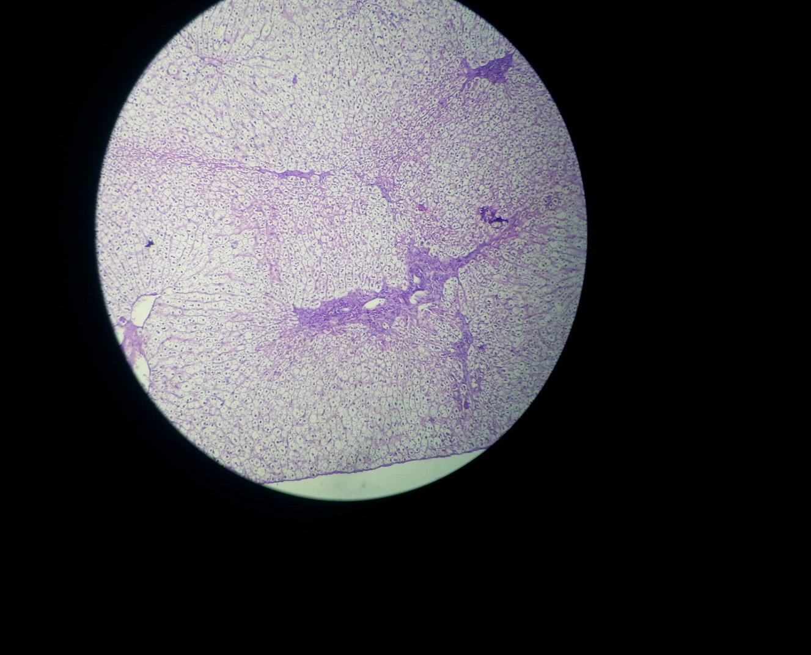

Picture (2,3) : exposed to paracetamol only
Severe fatty change, infiltration of mononuclear cells around bile duct, infiltration was also in the parenchyma of the liver(follicular shape - like) , congestion in venule. (score 3)
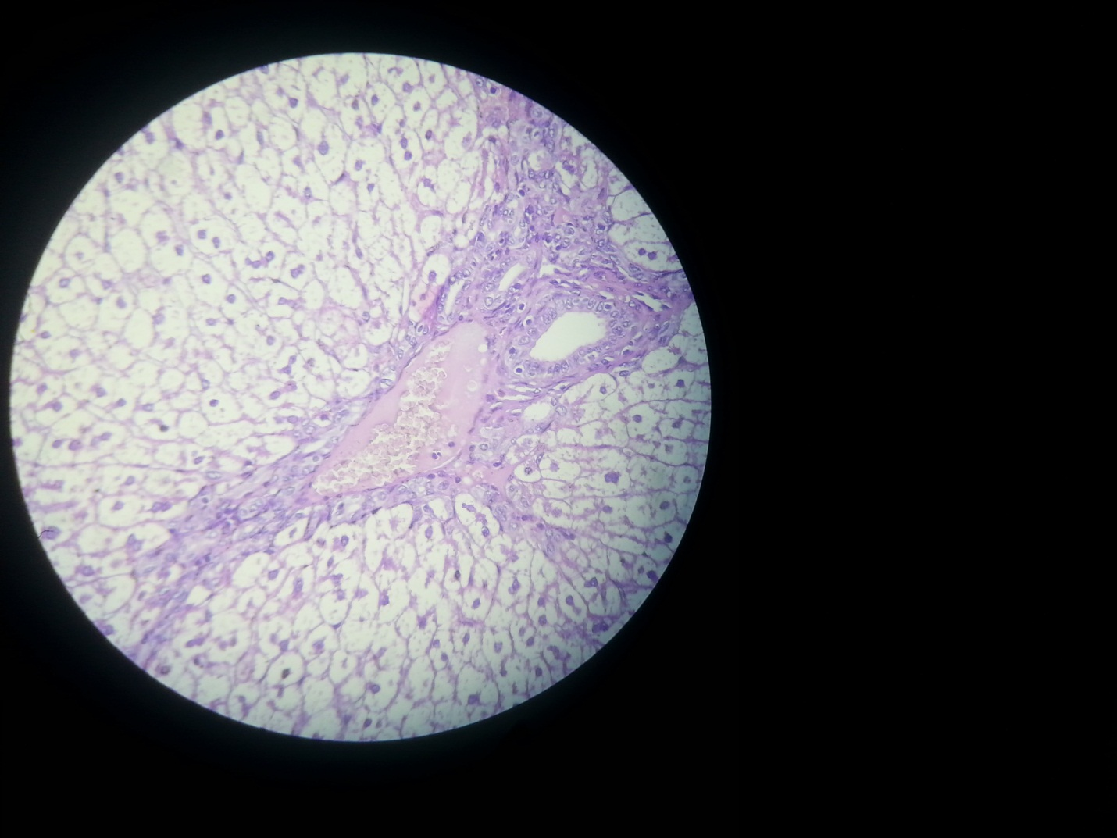
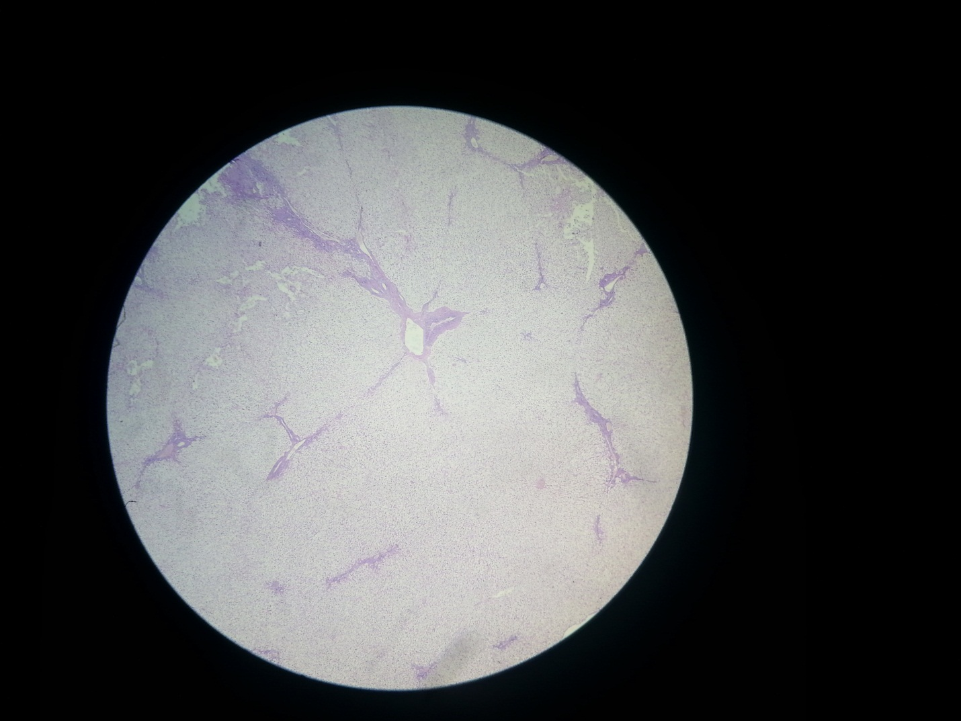

Picture (4) : treated with extract after exposure to paracetamol
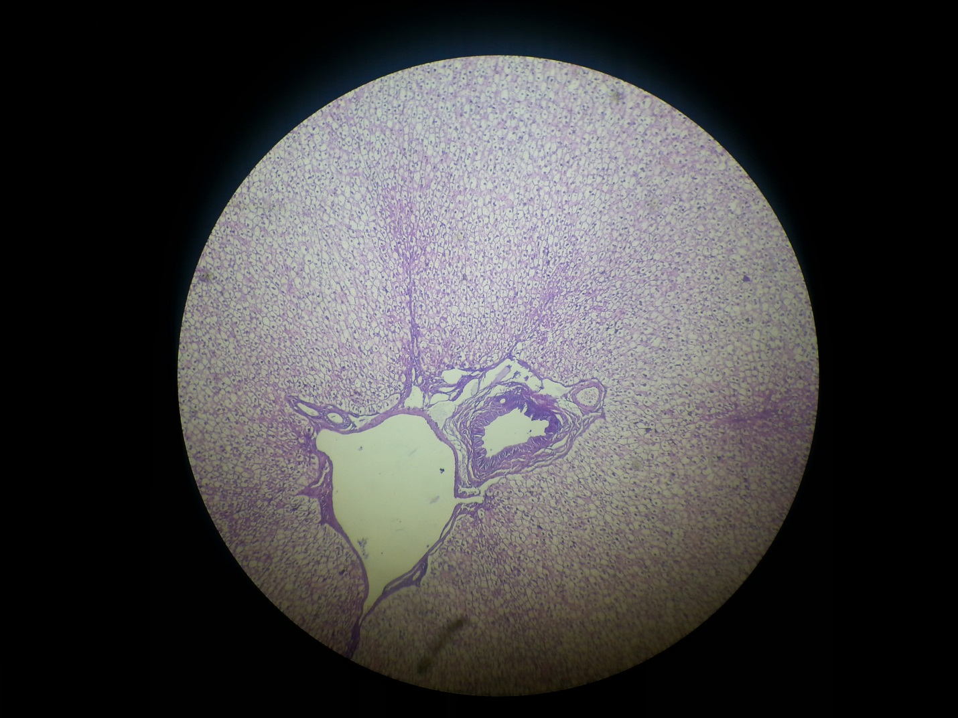
infiltration of mononuclear cells around bile duct and around the portal duct in the liver, infiltration was also in the parenchyma of the liver(follicular shape - like) . (score 2)

Picture ( 5): treated with Cordia extract before and after exposure to paracetamol
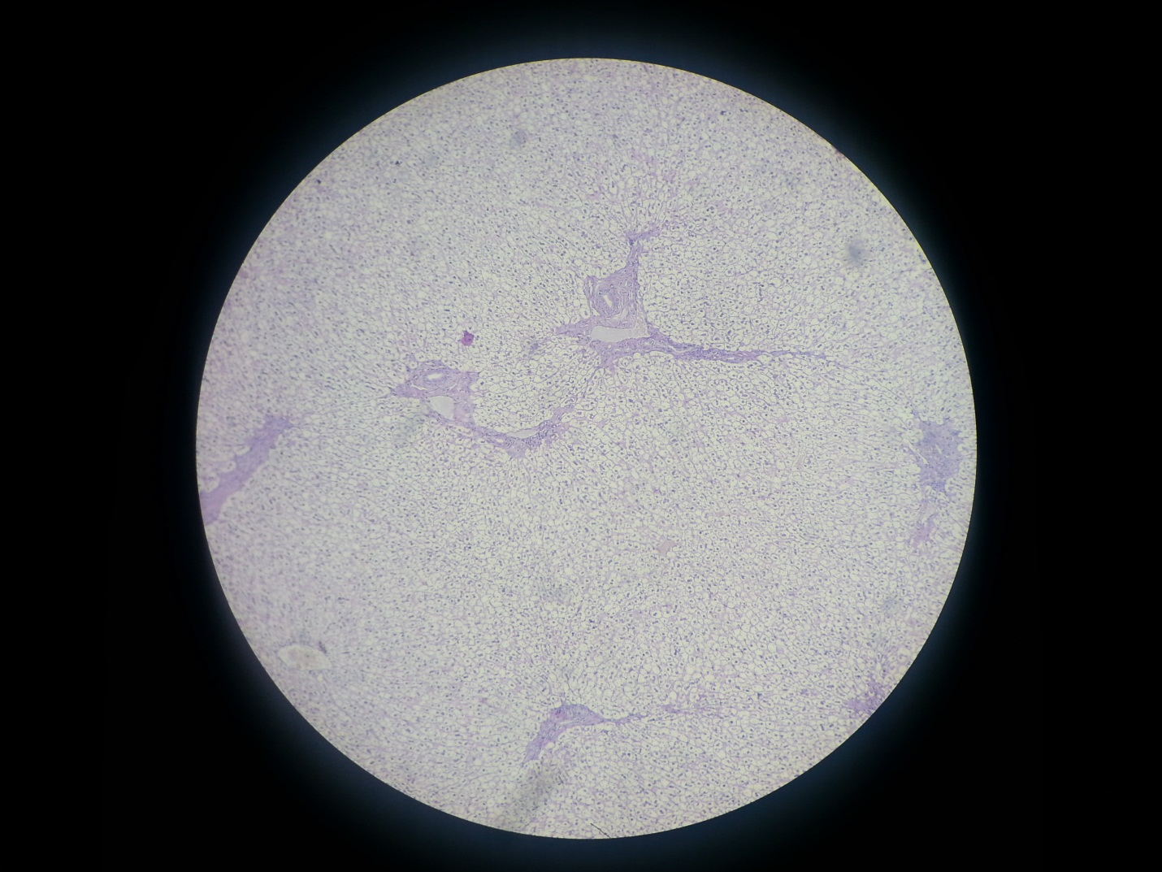
Congestion in the central venule , infiltration of mononuclear cells around bile duct and around the portal duct in the liver, infiltration was also in the parenchyma of the liver(follicular shape - like), chromatolysis in the nuclei of the hepatocytes . (score 1)

Discussion
Paracetamol is generally used as an analgesic and antipyretic drug (Parmer et al., 2010). When taken in overdose (200mg /kg) it produces potent hepatotoxicity, therefore it is widely used as a hepatotoxicant in experimental animals (Dadly, et al., 2008). ALT, AST, and serum bilirubin levels are commonly used biochemical parameters to evaluate liver injury on induction of paracetamol hepatotoxicity, the ALT, AST and bilirubin levels increase in the circulation because they are cytoplasmic in location and released into circulation after cellular damage (Parmer et al., 2010). The elevated level of these entire marker enzymes observed in the group I, paracetamol treated rabbits, corresponds to the extensive liver damage induce in our study. the levels of these biomarkers in pre -treated animals with A. maurorum ( 500 mg /kg) were found to be lower than the paracetamol intoxicated group indicating that this dose can protects the paracetamol induced hepatic damage ( Rehman et al., 2015). A. maurorum possesses flavonoids and tannins which were conformed phytochemical analysis of the extract and these both groups are well recognized for their hepatoprotective action. Saponins, alkaloids, flavonoids and triterpenoids are phytochemical constituents of A. maurorum possessing antioxidant , free radical scavenging ability and inhibition of lipid peroxidation (Faure, et al.,1990; Jin, et al., 2011).

Conclusion and recommendation
The findings of this study indicate that the aqueous – ethanol extract of C,. dichotoma at a dose 300 mg /kg exhibits significant hepatoprotective activity by reducing elevated levels of biochemical enzymes. further studies are required to explore the active principle responsible for this hepatoprotective activity.

References
Alami, R. and Macksad, A. (1974). Medicinal plants in Kuwait, Al-Assriya Press, Kuwait: 6.
Al-Awadi, F.M.; Srikumar, T.S.; Anim, J.T. and Khan, I. (2001). Anti-inflammatory effects of Cordia myxa fruit on experimentally induced colitis in rats. Nutrition; 17 (5): 391-396.
Alkofahi, A. and Atta, A.H. (1999). Pharmacological screening of the anti- ulcerogenic effects of some Jordanian medicinal plants in rats. J. Ethnopharmacol.; 67: 341-345.
Afzal, M.; Obuekwe, C.;Shuaib, N. and Baraksat, H.(2004). Photosynthetic pigment profile Cordia myxa L. and its potential in folklore medicinal application. Journal of food Agriculture and Environment; 2(20): 114-120.
Bhardwaj, A.;; Khatri, P.; Soni, P.M.L.; Ali, D.J.( 2011). Potential herbal hepatoproteci. J Adv Sci Res Ves drug – a review; 2(2): 15-20)
Bort, R.; Ponsoda,X.; Jpver, R.; Gomez-Lechon, M.J.; Castell, J.V.(1999). Diclofenac toxicity to hepatocytes: a role for drug metabolism in cell toxicity. J Pharmacol Exp Ther; 288: 65-72.
Coles, E.H. (1986). Veterinary Clinical Pathology, 4th ed. W.B/. Saunders Company, Philadelphia, USA: 10-75.
Daly, FF.; Fouutain JS.; Murray L.; Graudins, A.; Buckely, NA. (2008). Guidelines for the management of paracetamol poisoning in Australia and New Zealand- explanation and elaboration. A consensus statement from clinical toxicologists consulting to the Australasian poisons information centers. Med J Aus; 188 (5): 296-301.
Faure, M.; Lissi, E.; Torres, R.; Vidella, LA. (1990). Antioxidant activity of liginin and flavonoids. Phytochem.; 29: 3773-3775.
Ficarra, R.; Ficarra, P.; Tommasini, S.; Ragsa, S.; Barbewra, R. and Rapisarda, A. (1995). Leaf extracts of some Cordia species; analgesic and anti-inflammatory activities as well as their chromatographic analysis. Farmaco.; 50 (4): 245- 256.
Friedman, Scott E.; Grendell, James, H.; McQuasid, Kenneth R (2003). Current diagnosis and treatment in gastroenterology. New York: Lang Medical Books/ McGraw- Hill: 664-679.
Friedman, Peter F. (2006). GI/ Liver Secrets: with Student Consult Acess. Sanit Louis: C.V. Mosby et al., 2006.
Jin, X.; Qian, J.; Lu, Y. (2011). The role of hepato-protective effect of a fllavonoid- rich extract of Saliva plebeian R.Br. on carbon tetrachloride induced acute hepatic injury in mice. J. Med Plant Res; 5(9): 1558-1563.
Ka”hko” nen, M.P., Hopia, A.I., Vuorela, H.J., Rauha, J.P., Pihlaja, K., Kujala, T.SD., Heinonen, M., (1999). Antioxidant activity of plant extracts containing phenolic compounds. J. of Agri & Food Chem; 47 (10): 3954-3962.
Masubuchi, Y.; Yamada,S.; Horie, T.( 2000). Possible mechanisms of hepatocyte injury induced by diphenylamine and its structurally related NSAIDS. J pharmaco. Exp Ther ; 292: 982-987.
Ostapowicz, G.; Fontana, R.J.; Schiodt, F.V.; Larsoin, A. Davron, J.T.; Steven, H.B.; Timothy, M.; Reish, J.(2002). Results of a prospective study of acute liver failure at 17 tertiary care centers in the United States. Ann Inter Med ; 137: 047- 954.
Pang, S.; Xin, X.; Stpierre, MV. (1992). Determinants of Metabolic Disposition. Rev. Pharmacol. Toxicol.; 32: 625-626.
Parmar, SR.; Vashrambhal, P.H.; Kalia, K. (2010). Hepatoprotective activity of some plants extract against paracetamol induced hepatotoxicity in rats. J herb med toxicol; 4 : 101-106.
Pietta, P.G. (1998). Flavonoids in medicinal plants. In C.A. Rice- Evans & L. Packer(Eds.). Flavonoids in health and disease, New York; Dekker:61-110.
Rates, S.M.K. (2001). Plants as source of drugs. Toxicon; 39(5): 603-613
Saravana, A Kumar.; Gandhimathi, R.; Senthil K.K.; ; Kusuma P.K.( 2009). Hepatoprotective potential of Cordia subcordata lam. Against carbon tetra chloride (CCl4) – induced hepatotoxicity in Wistar albino rats. J. Biomed Sci and Res; 1(1): 19-26.)
Schmeda- Hirschmann, G. and Yesilada,E. (2005). Traditional medicine and gastroprotective crude drugs. J. Ethnopharmacol.; 100(2): 61-66.
Simon, J.E., Morales, M.TR., Phippen, W. B., Viera, R.F. Hao, Z. Basil. (1999). A source of aroma compounds and a popular culinary and ornamental herb. In J. Janick (ed.), Perspectives on new crops and new uses. Alexandria, VA; ASHS Press: 499-505.
Sharma, A.; Chakrabirti, K.K.; Handa, S.S. (1991). Anti- hepatotoxic activity of some Indian herbal formulations as compared to sliymarin. Fitoterapia; 62: 229- 235.
Sheetal, V. and Singh, SP.(2008). Current and future stratus of herbal medicine. Vet World; 1: 347- 350.
Srivastava SK, Srivastava SD. (1979). Taxifollin 3, 5- dihamnoside from the seeds of Cordia dichrotoma, Phytochemistry; 18:205-208.
Steel, R. G. D.; Torrie, G.H.; Dickey, D.A. (2007). Principles and procedures of statistics. 3rd Ed. McGraw Hill, New York: 1746-62.
Subramoniun,A.; Pushpangadan, P.; (1999). Development of Phytomedicines for liver disease. Indian J Pharmacology; 31: 166-175.
Sun, Chu, Wu, Liu. (2002). Antioxidant and anti-proliferative activities of common fruits. J. of Agri and Food Chem;50: 7449-7454.
The Wealth of India, Raw Materials. (1950). A Dictionary of Indian Raw Material and Industrial Products; 9 (Council of Scientific & Industrial Research, New Delhi: 293-295.
Wang, BJ.; Liu, CT.; Tseng, CY.; Wu, CP.; Yu.ZR.( 2004). Hepatoprotective and antioxidant effects of Bupleurum kaoi Liu (Chaoet Chuang) extract and its fractions fractionated using supercortical CO₂ on CCl₄ induced liver damage. Food Chem Toxicol; 42: 609- 17.
Walker, A. M. (1997). Quantitative studies of the risk of serious hepatic injury in persons using nonsteroidal anti- inflammatory drugs. Arthritis Rheum; 40: 201-208.
Ward, FM.; Daly, MJ.; (1999). Hepatic disease. In Walker R., Edwards C.; editors. Clin Pharm Ther. Churchil Livingston: New York: 195-212.
Wolf, P.L.(1999). Biochemical diagnosis of liver disease. Indian J. Clin Biochem; 14: 59.
Zhang, A.; Sun, H.; Wang, X..(2013). Recent advances in natural products from plants for the treatment of liver diseases. Eur J Med Chem; 63: 570-577.
Zimmerman, H.J. (1990). Update on hepatotoxicity due to classes of drugs in common clinical use: non- sterpoidal drugs, anti- inflammatory drugs, antibiotics, anti- hypertensives and cardiac and psychotropic agents. Semin Liver Dis.; 10: 322-338.

الخلاصة
لتقيم الفعالية واقية الكبد لمستخلص ( مائي – ميثانول)( 70:30%) لثمار البمبر ضد الاذى المحدث بالكبد من قبل البراسيتمول تجريبيا في الارانب . تم اخضاع 16 ارانبا ناضجا، من الذكور ، بوزن 1- 1.9 كغم ، وبعمر 1-2 سنوات للتجربة. تركت الحيوانات في غرفة مكيفة بدرجة حرارة 20-26 ºم ، وتركت حرة للعلف الاخضر والمركز ، والماء. قسمت الحيوانات الى 4 مجموعات بواقع 4 في كل مجموعة : عولجت حيوانات المجموعة الاولى بالمستخلص النباتي بجرعة 300 ملغم \ كغم لمدة 9 ايام ، ثم عرضت الى جرعة البراسيتمول بجرعة 250 ملغم \ كغم في الخلب معلق بالسائل الملحي الطبيعي لمدة 9 ايام متتالية واستمر العلاج بالمستخلص لغاية اليوم 18. اما حيوانات المجموعة الثانية فتركت بدون تعرض للمستخلص النباتي خلال الايام 9 الاولى ثم عرضت الى البراسيتمول بجرعة 250 ملغم \ كغم في الخلب معلق بالسائل الملحي الطبيعي لمدة 9 ايام، مقروننا بالمستخلص النباتي بجرعة 300 ملغم \ كغم من وزن الجسم لغاية اليوم 18. اما حيوانات المجموعة الثالثة فتركت بدون تعرض للمستخلص النباتي خلال الايام 9 الاولى ثم عرضت على البراسيتمول بجرعة 250 ملغم \ كغم في الخلب معلق بالسائل الملحي الطبيعي لمدة 9 ايام. في حين تركت حيوانات المجموعة الرابعة بدون علاج بالمستخلص النباتي ولم تتعرض للبراسيتمول كمجموعة سيطرة. وفي اليوم 18 تم ذبح الحيوانات حيث اخذ الدم للحصول على المصل لتحديد مستويات الانزيمات (GPT, GOT, TSB, TSP, RBS,BUN, Creatin)واخذ نماذج من الكبد للفحص النسيجي. من المعايير الاخرى التي اعتمدت الفحوصات السريرية حيث اخذ معدل التنفس ، وسرعة ضربات القلب ، وحرارة الجسم ، ووزن الحيوان اسبوعيا خلال التجربة ، فضلا عن الفحوصات الدموية ،تحديد مستوى الخضاب ، وحجم الخلايا المرصوصة ، وزمن التخثر والنزف ، وعد الخلايا البيض التفريقي والكلي . اظهرت نتائج الدراسة ان مستويات المعايير الكيميوحيوية ارتفعت في الارانب المعرضة للبراسيتمول مقارنة بالمجموعة الطبيعية. المستخلص بحرعة 300 ملغم \ كغم من وزن الجسم اظهر هبوط معنوي في القيم الكيميوحيوية ALT, ASDT , TSB)) . الحماية للكبد ايضا ظهرت من خلال الفحوصات النسيجية. من هذه النتائج يمكن الاستنتاج ان ثمار البمبر تمتلك تاثير حامي للكبد بشكل مهم ضد التسمم الكبدي المحدث بالبراسيتمول ويمكن ان يعود هذا الى وجود الفلافونويد والتانتين.

